**Contain**

# CHANGES for Dairy McKay

1. The database (mentioned in MySQL) “takefeedback” for ecw

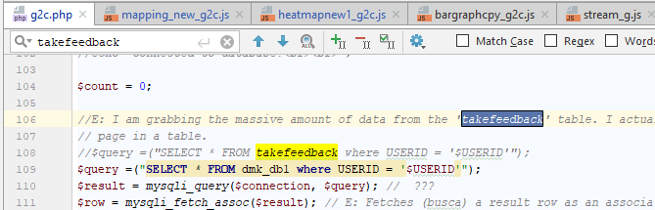

1. DATA (2 lines) L.46 L.47

Change the JSON (js) data

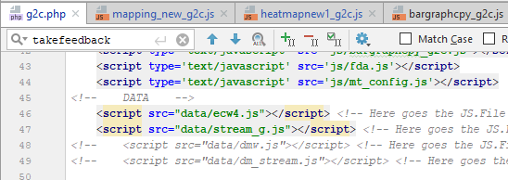

1. Map center position L.51

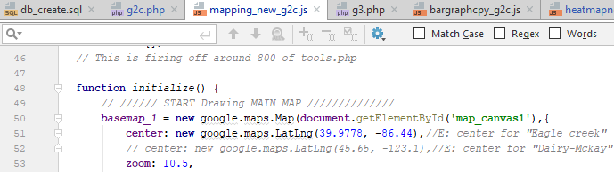

1. The type of variable “toString” (1 line) in “mapping_new_g2.js”

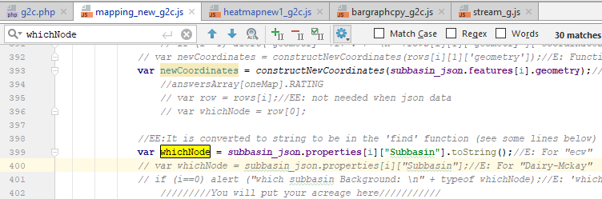

1. Change the length of “PFR_meanVals_array” from to 126 to 38 (4 times)

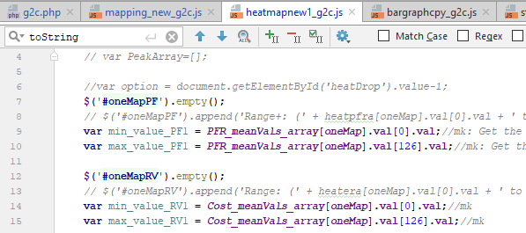

1. The type of variable “toString” (8 lines)

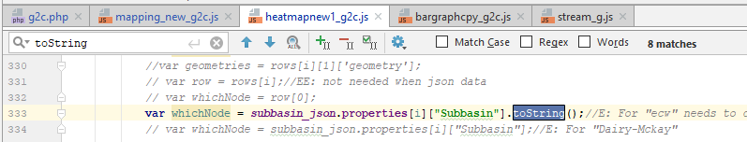

1. Make sure that json data of watershed and stream have the following characteristic:

* No “multipolygon”.
* Kip the same name of features, such as: “Subbasin”, “area_ac”, etc.

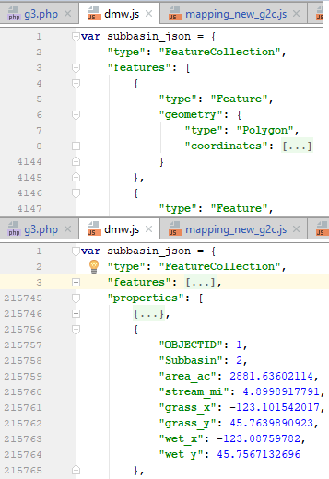 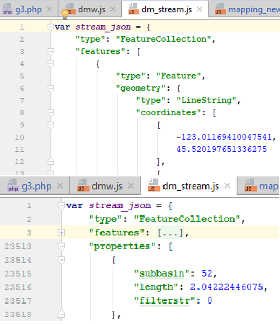

1. Make this change in “g3.php”. “0.0” for “ecw” and just “0” for “Dairy-Mckay”

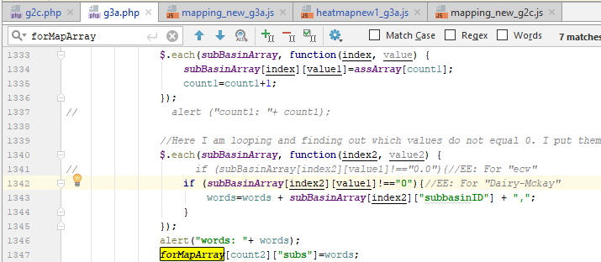

1. These two lines of code in “mapping_new.js” are case sensitive. Change “Subbasin” for “ecw” by “subbasin” for “Dairy McKay”, because the JSON data for “ecw” considers “Subbasin” with uppercase and “Dairy McKay” with lowercase

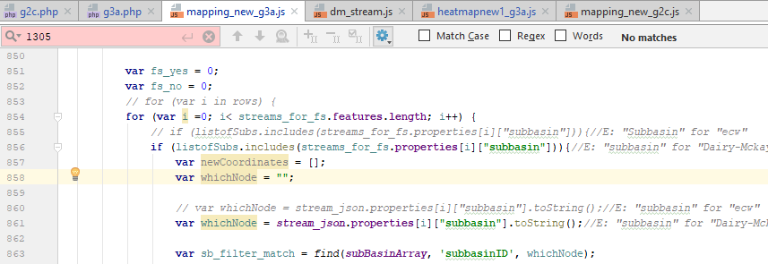

1. Change the center of coordinates of each heatmap in PFR, P, SR, and NR heatmap. The zoom can be 9.5 or 10. See below.

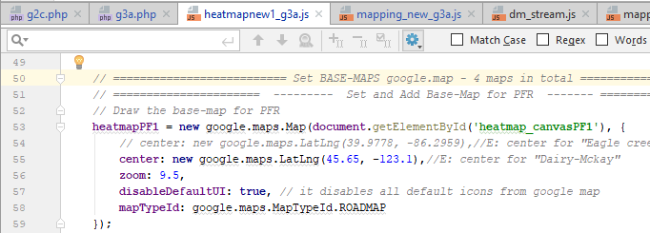

1. In ‘g2.php’, change the number of sub-basins from 130 to 50. Line 492 (php part)

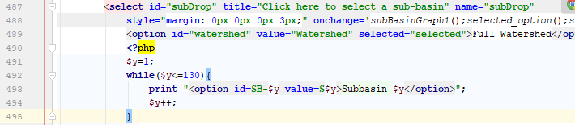

1. In ‘mapping_new_g2’, change the variable ‘n_sb’ (number of sub-basins)

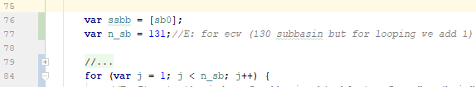

1. In mapping_new_g2’, change the variable ‘n_sb’ (number of sub-basins)

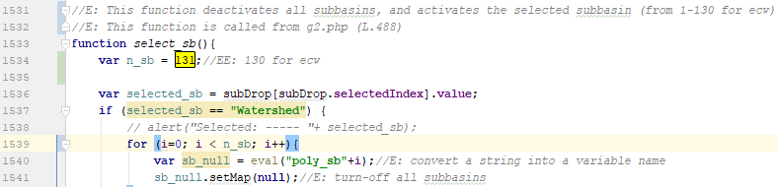

1. dasdsad

# CHANGES needed to use the Database in three different ways

1. In g2.php, Line 1217, write the number option for “database_option”

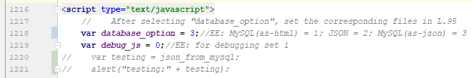

1. In g2.php, Line 95, make the needed changes for the selected option

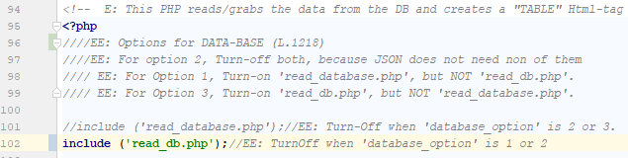

# CHANGES needed when new columns are added into the MySQL DB

When new columns are added into the MySQL database, the order of columns are changed as well. Therefore, these following changes in the code are needed.

1. In g2.php (L.1406), to use DB as MySQL format (option 1), it is needed to change the column number when S1, S2, …, etc. star. In other words, change the number in yellow (18).

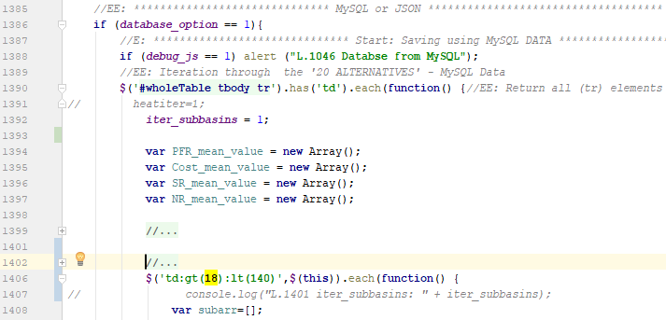

1. In g2.php (L.1277), to use DB as JSON format (option 3), it is needed to change the column number when S1, S2, …, etc. star and finish (in this case, it refers to the JSON format file). In other words, change the number in yellow (19 and 149) (149-19 = 130, Eagle Creek Watershed has 130 subbasins)

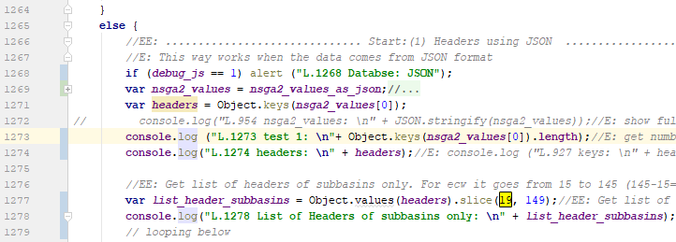

1. To use DB as JSON format (Option 2. From ‘js’ file), it is needed to create a new js file considering new columns. Change the number in yellow (19 and 149) (149-19 = 130, Eagle Creek Watershed has 130 subbasins). In some cases, these numbers already were changed in the previous case (Option 3)

# How to insert a CSV/EXCEL file into MySQL

1. Save your excel file as CSV with your desired header
2. Open the MySQL and go to the Database where you want to import the CSV data.
3. Once you are inside of the database, click on “Import”.
4. In the new window, choose your CSV file (upload your CSV file), and check the box “The first of the line contains ….” (see the red box below). By clicking this box, headers of you CSV file will be setup as header on your MySQL table as well.

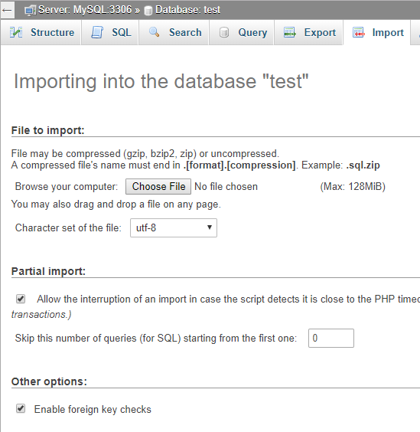

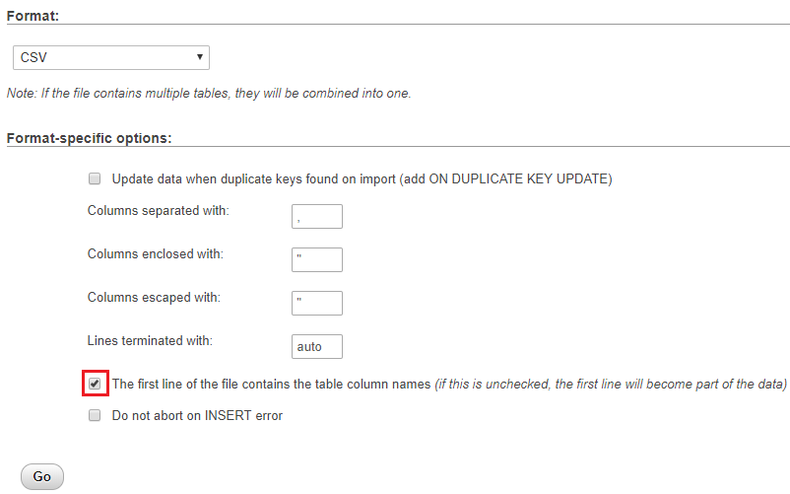

1. Click “Go”. Then, a table with a default name will be create.
2. Rename the table with a desired name using this query (notice the apostrophe key is located below the `esc` key).

RENAME **TABLE `**tb1` **TO `**tb2`, `tb3` **TO `**tb4`;

# COPY A TABLE (MAKE A DUPLICATE TABLE)

1. Select the database you wish to copy (by clicking on the database from the phpMyAdmin home screen).
2. Once inside the database, select the Operations tab.
3. Scroll down to the section where it says "Copy database to:"
4. Type in the name of the new database.
5. Select "structure and data" to copy everything.  Alternately, you can select "Structure only" if you want the columns but not the data.
6. Check the box "CREATE DATABASE before copying" to create a new database.
7. Check the box "Add AUTO_INCREMENT value."
8. Click on the **Go** button to proceed.

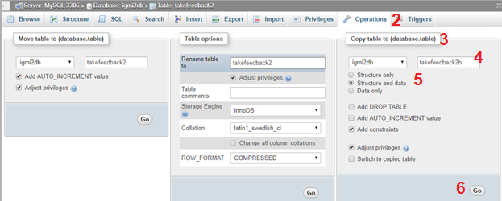

/*UPDATE takefeedback2b SET RATING4 = 1,2,3;*/

LOAD DATA LOCAL INFILE 'F:\\WRESTORE\\onecolumn.csv'

INTO TABLE takefeedback2b

FIELDS TERMINATED BY ','

LINES TERMINATED BY '\r\n'

(RATING4);

# NEXT Tasks

1. Run WRESTORE for Dairy-Mckay watershed (done)
2. Set the json file (data.js) into the virtual web (done)
3. Convert the big database DDBB into json (done)
4. Implement Bootstrap (done)
5. Corrections for DR. Kristen experiment (done)
6. Modify scale of heatmap legends (done)
7. Width responsive of bar plots and heatmaps (done)
8. Set a Quit option at the end of the alternative 20 (done)
9. Install arcmap in my laptop (done)
10. Highlight the selected sub-basin (done)
11. Insert the user’s rating into MySQL for the alternative in curse.
12. Design the experiment

# Links

Curso de bootstrap para ver classes

<https://www.youtube.com/watch?v=7s1RjItUBqU&index=1&list=PLL0TiOXBeDagsYUYFO9WMwDtuDuoGZVB9>

Use google drive as database and to access through JavaScript

<https://www.youtube.com/watch?v=-7YH6rdR-tk>

<https://bytutorial.com/tutorials/google-api/introduction-to-google-drive-api-using-javascript?fbclid=IwAR3OMDB3FZsG8sQSnH7bbFXuMpgWa3u-oLltqgO5JuqEBwdzOn9pjXwZbFI>

<https://advancedweb.hu/2015/05/26/accessing-google-drive-in-javascript/>

my page

<https://noayarae.github.io/Custom-basemap-leaflet/index.html>

GIT Atlassian-tutorial

<https://www.atlassian.com/git/tutorials/saving-changes/gitignore>

<https://confluence.atlassian.com/bitbucket/checkout-a-branch-into-a-local-repository-313466957.html>

‘JSON validator’ and ‘convertor from CSV to JSON’

<https://jsonlint.com/>

<http://www.convertcsv.com/csv-to-json.htm>

jQuery split-resize floating sidebar

<https://codepen.io/istrasoft/pen/unKsl>

How to make a div take the remaining height

<https://www.whitebyte.info/programming/css/how-to-make-a-div-take-the-remaining-height>

Media query CSS

<https://www.youtube.com/watch?v=VWL7I71pU2A&t=613s>

<https://www.youtube.com/watch?v=JQTSFhZ0S-I&t=634s>

https://www.vectorstock.com/royalty-free-vector/primary-colors-of-red-yellow-blue-and-mixing-vector-23214758



Color mixer of n-colors:

<https://www.colorhexa.com/99cc66>

Color mixer of 2 colors

<https://meyerweb.com/eric/tools/color-blend/#99FF00:33CCFF:1:hex>

Green: #99FF00

Cyan: #33CCFF

Orange: #FF9933

Yellow: #FFFF66

# CREATE TABLE takefeedback4 LIKE takefeedback2, and upload data from CSV to MySQL

* Query to create a new table (“takefeedback4”) with same format as other table (“takefeedback2”)

CREATE TABLE takefeedback4 LIKE takefeedback2;

* Query to upload data from CSV file into a MySQL table called “takefeedback4” (created above)

LOAD DATA LOCAL INFILE 'F:/WRESTORE/takefeedback_json4.csv'

INTO TABLE takefeedback4

FIELDS TERMINATED BY ','

ENCLOSED BY '"'

LINES TERMINATED BY '\n'

IGNORE 1 ROWS;

LOAD DATA LOCAL INFILE 'F:/WRESTORE/takefeedback_json3.csv'

INTO TABLE takefeedback3

FIELDS TERMINATED BY ','

ENCLOSED BY '"'

LINES TERMINATED BY '\n'

IGNORE 1 ROWS;

Video of Decision making under certainty, uncertainty and risk

<https://www.youtube.com/watch?v=XmniFPHg1WU>

How to change the upper and lower bound of barplots